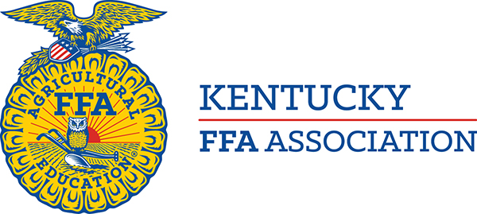

To: State FFA Officer Candidates

From: Matt Chaliff, Executive Secretary
Kentucky Association FFA

Date: January 2025

Subject: State Officer Dates

Following are some major activities that the 2025-2026 State Officers will be expected to attend. Candidates must ensure that they can attend all events prior to running for office.

SCHEDULE

June 18-25 Base Camp Training, Lexington

June-July FFA Leadership Training Center (officers will represent the Association for one week each)

July 14-18 State Officer Summit- Washington, D.C.

July 31-August 5 Advocacy and Communication Training- Frankfort

Aug. 11-24 Kentucky State Fair, Louisville (all officers will work several days of the fair)

October 27-Nov. 1 National FFA Convention, Indianapolis

